***Secondary Loss in bends and pipe fittings***

**Introduction:**

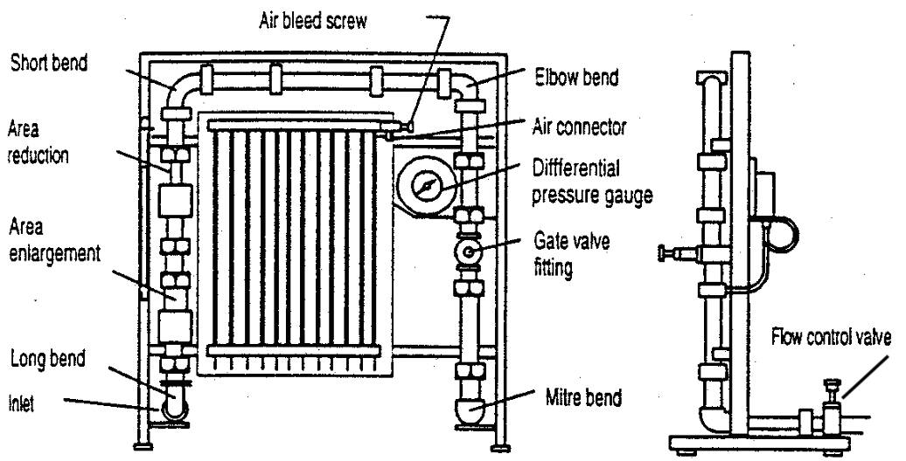 Energy losses in pipe flows are the result of friction between the fluid and the pipe walls and internal friction between fluid particles. Minor (secondary) head losses occur at any location in a pipe system where streamlines are not straight, such as at pipe junctions, bends, valves, contractions, expansions, and reservoir inlets and outlets. In this experiment, minor head losses through a pipe section that have several bends, transitions and fitting will be measured as shown in Figure [1].

**Figure 1**. Schematic drawing of the energy-loss apparatus

# Objective:

The objectives of this lab are to measure head losses through bends, transitions, and fittings, and to use these measurements to estimate the loss coefficients for each transition or fitting.

|  |  |  |  |  |  |  |
| --- | --- | --- | --- | --- | --- | --- |
| **No** |  | **1** |  |  | **2** |  |
|  | Δ**h**  **(mm)** | **ΔV**  **(lit.)** | **t**  **(Sec.)** | Δ**h**  **(mm)** | **ΔV**  **(lit.)** | **t**  **(Sec.)** |
| **Mitre** | **29** | **5** | **28.5** | **85** | **3** | **11** |
| **Elbow** | **35** | **5** | **28.5** | **262** | **3** | **11** |
| **Short bend** | **21** | **5** | **28.5** | **32** | **3** | **11** |
| **Long bend** | **12** | **5** | **28.5** | **23** | **3** | **11** |
| **Enlargement** | **-9** | **5** | **28.5** | **-49** | **3** | **11** |
| **contraction** | **26** | **5** | **28.5** | **46** | **3** | **11** |

**Readings:**

**Calculation:**

***For Mitre bend:***

**Qact = =**  = 0.175 L/s

**v=Q/A**= $\frac{0.175×{10}^{-3} }{301.7x{10}^{-6}}$ = 0.58 m/*s*

**Δh= K $\frac{v^{2}}{2g}$**

**K= $\frac{2×9.81x29x{10}^{-3}}{{(0.58)}^{2}}$** = 1.69

**Results:**

|  |  |  |  |
| --- | --- | --- | --- |
| **K** | **1** | **2** | **Average** |
| **Mitre** | **1.69** | **2.04** | **1.86** |
| **Elbow** | **2.034** | **6.29** | **4.16** |
| **Long bend** | **0.697** | **0.557** | **0.625** |
| **Short bend** | **1.22** | **0.768** | **0.994** |
| **Enlargement** | **- 1.676** | **- 3.75** | **- 2.713** |
| **Contraction** | **1.479** | **1.078** | **1.278** |

**Conclusion:**

The K-value, Resistance Coefficient allows the user to characterize the pressure loss through fittings in a pipe. The K-value represents the multiple of velocity heads that will be lost by fluid passing through the fitting.